SYDNEY C Roofing

Design Structural Analysis

Order number 20/stat.15 2020-07-29
Author: ing. V. Chobot, Tábor, Buzulucká 2332
Authorized Civil Engineer, ČKAIT 0101501

Complied for: ALBIXON a.s. Cintlovka 535, 268 01 Hořovice

Volume content:

Technical report pp. 2-3
Drawings of the structure 1 and 2 pp. 4-5
Calculation model p. 6
Structural analysis of KZS 1 pp. 7-10
Structural analysis of KZS 2 pp. 11-14
Conclusion pp. 15

Technical report:
Assessment of the stability of the “SYDNEY C 5000 x 2190 mm” skeleton roof structure made of aluminium profiles according to EN AW 6063. The roof will be installed on the outside. Climate load specified by the customer: Snow of 0.6 kNm⁻², wind with a reference pressure corresponding to 120 km/h. The shape of the skeleton structure is specified according to the drawing attached. The structure will be provided with a lightweight roof cladding made of organic glass panels with an adjustable shape, 4 – 6 mm, or polycarbonate honey-comb panels. The structure will be anchored to a travel rail in the bases of the arches.
Assessed loading conditions:
ZS 1. Self-load weight of 0.111 t, including roofing, for a span of 5 m.
ZS 2. Vertical surface snow load of 0.60 kNm⁻².
ZS 3. Horizontal roof surface wind load ( v_{ref} = 33.33 ms⁻¹; γ_{air}= 1.25 e⁻³ tm⁻³; ; q= 7.5 kNm⁻²; suction of 3.75kNm⁻²).
Computation load combinations:
Combination of roof load KZS 1 = 1.1 x ZS 1 + ZS 2; snow load of 0.6 kNm⁻².
Combination of roof load KZS 2 = 1.1 x ZS 1 + ZS 3; super position of wind load of 33.33 kNm⁻¹.
Standard references:
Publication date: March 1, 2010
Execution of steel structures and aluminium structures – Part 1: Requirements for conformity assessment of structural components.
EN 1090-1:2010/Z1 (732601), Date of issue: September 1, 2010 *Amendment
Execution of steel structures and aluminium structures – Part 1: Requirements for conformity assessment of structural components.
EN 1090-3 (732601), Date of issue: March 1, 2009
Execution of steel structures and aluminium structures – Part 3: Technical requirements for aluminium structures.
EN 1991-1-3 (730035), Date of issue: June 1, 2005
Eurocode 1: Loads on structures - Part 1-3: General loads - Snow loads.
EN 1991-1-3:2005/Correction 1 (730035), Date of issue: February 1, 2010 *Correction
Eurocode 1: Actions on structures - Part 1-3: General actions - Snow loads.
EN 1991-1-3:2005/Z1 (730035), Date of issue: October 1, 2006 *Amendment
Eurocode 1: Actions on structures - Part 1-3: General actions - Snow loads.
EN 1991-1-3:2005/Z2 (730035), Date of issue: February 1, 2010 *Amendment
Eurocode 1: Actions on structures - Part 1-3: General actions - Snow loads.
EN 1991-1-3:2005/Z3 (730035), Date of issue: March 1, 2010 *Amendment
Eurocode 1: Actions on structures - Part 1-3: General actions - Snow loads.
EN 1991-1-4 (730035), Date of issue: April 1, 2007
Eurocode 1: Loads on structures - Part 1-4: General loads - Wind loads.
EN 1991-1-4:2007/A1 (730035), Date of issue: October 1, 2010 *Amendment
Eurocode 1: Actions on structures - Part 1-4: General loads - Wind loads.
EN 1991-1-4:2007/Correction 1 (730035), Date of issue: September 1, 2008 *Correction
Eurocode 1: Actions on structures - Part 1-4: General loads - Wind loads.
EN 1991-1-4:2007/Correction 2 (730035), Date of issue: May 1, 2010 *Correction
Eurocode 1: Actions on structures - Part 1-4: General loads - Wind loads.
EN 1991-1-4:2007/Correction 3 (730035), Date of issue: January 1, 2011 *Correction
Eurocode 1: Actions on structures - Part 1-4: General loads - Wind loads.
EN 1991-1-4:2007/Z1 (730035), Date of issue: March 1, 2010 *Amendment
Eurocode 1: Actions on structures - Part 1-4: General loads - Wind loads.

List of specified and used materials:
E1, E2 | [MPa] | Modules of elasticity (E2 only for ortho-tropic material)
ni |  | Poisson effect
Gamma | [t/m3] | Bulk density
K1, K2 | [kN/m3] | Coefficients of thermal expansion
Attenuation |  | Decrement of attenuation

Material | Type | E 1 | ni | Gamma | K 1 | E 2 | K 2 | Attenuation
 |  | [MPa] |  | [t/m3] | [kN/m3] | [MPa] | [kN/m3]
Aluminium | STEEL | 72000.000 | 0.330 | 2.700 | 2.340e-05 |  |  | 0.010
PC 1000 | OTHER | 2400.000 | 0.360 | 1.200 | 6.500e-06

Material | Volume | Weight
 | [m3] | [t]
Aluminium | 0.023 | 0.063
PC 1000 | 0.040 | 0.048
Total |  | 0.111

List of cross-sections:

Iy, Iz | [mm4] | Main moments of inertia
Ik | [mm4] | Moment of stiffness in simple twist
Beta y, beta z |  | Shear stiffness coefficients
P |  | Full cross section
S |  | Combined
D |  | Partial

Cross section | Type | Material | Area | ly | Iz | Ik | beta y | beta z
 |  |  | [m2] | [m4] | [m4] | [m4]
01-006 | S |  | 5.465e-04 | 1.066e-07 | 1.527e-07 | 8.599e-09 | 0.590 | 0.599
- External outline | D | Aluminium | 5.465e-04 | 1.066e-07 | 1.527e-07 | 8.599e-09 | 0.590 | 0.599
03-003 | S |  | 1.310e-04 | 1.598e-08 | 7.640e-09 | 3.122e-10 | 0.482 | 0.525
- External outline | D | Aluminium | 1.310e-04 | 1.598e-08 | 7.640e-09 | 3.122e-10 | 0.482 | 0.525
- Hole No.1 | D | Aluminium | 1.310e-04 | 1.598e-08 | 7.640e-09 | 3.122e-10 | 0.482 | 0.525
03-001 | S |  | 3.277e-04 | 5.758e-08 | 4.807e-08 | 2.728e-09 | 0.711 | 0.415
- External outline | D | Aluminium | 3.277e-04 | 5.758e-08 | 4.807e-08 | 2.728e-09 | 0.711 | 0.415
01-008 | S |  | 8.620e-04 | 1.813e-07 | 3.703e-07 | 2.502e-08 | 0.734 | 0.390
- External outline | D | Aluminium | 8.620e-04 | 1.813e-07 | 3.703e-07 | 2.502e-08 | 0.734 | 0.390
01-028 | S |  | 2.869e-03 | 2.789e-05 | 1.017e-06 | 5.861e-08 | 0.532 | 0.760
- External outline | D | Aluminium | 2.869e-03 | 2.789e-05 | 1.017e-06 | 5.861e-08 | 0.532 | 0.760

Units used:
Geometry - length | mm | Deformation - displacements | mm
Geometry - angles | deg | Deformation - rotation | deg
Cross-sections - length | mm | Time | s
Loading, results - forces | kN | Temperature | °C
Loading, results - voltage | MPa | Mass | t
Loading, results - length | mm

Comparative calculation values for material according to EN AW 6063 (AlMgSi)
The structure significance for the service life is 25 years according to EN 1991-1.
Minimum tensile strength 245 MPa
Minimum yield strength R_{p} 0.2 200MPa
Derived comparative tension for EN AW 6063 σ = 142.3 MPa
Derived comparative tension for PC 1000 polycarbonate σ = 142 MPa

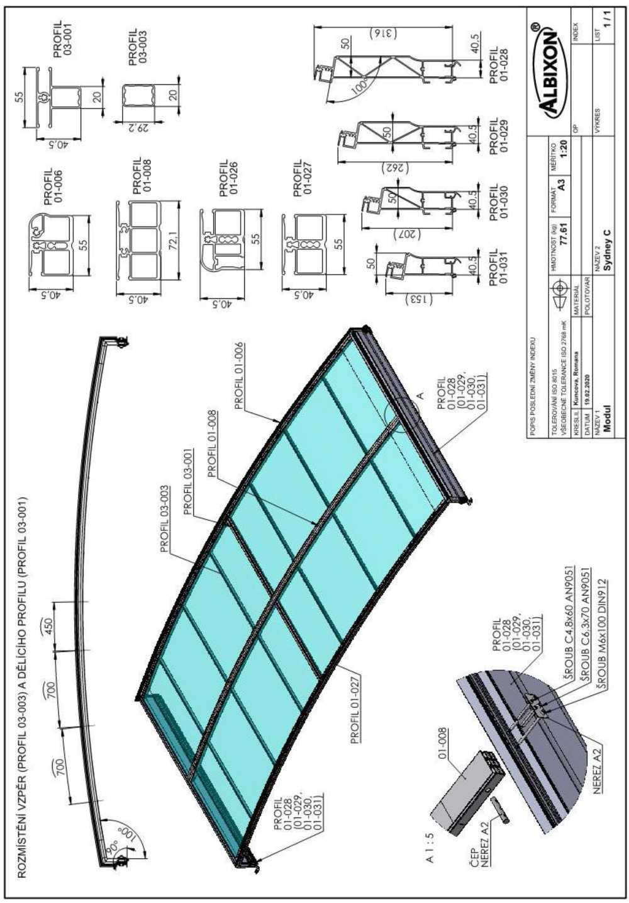

ROZMÍSTĚNÍ VZPĚR (PROFIL 03-003) A DĚLÍCÍHO PROFILU (PROFIL 03-001) | LAYOUT OF STRUTS (PROFILE 03-003) AND DIVIDING PROFILE (PROFILE 03-001)
PROFIL | PROFILE
ČEP | PIN
NEREZ | STAINLESS STEEL
ŠROUB | SCREW
POPIS POSLEDNÍ ZMĚNY INDEXU | DESCRIPTION OF LATEST INDEX CHANGE
TOLEROVANÍ ISO 8015 | TOLERANCE ISO 8015
VŠEOBECNÉ TOLERANCE ISO 2768 mK | GENERAL TOLERANCES ISO 2768 mK
KRESLIL | DRAWN BY
DATUM | DATE
NÁZEV 1 | TITLE 1
MATERIÁL | MATERIAL
POLOTOVAR | INTERMEDIATE
HMOTNOST (kg) | WEIGHT (kg)
NÁZEV 2 | TITLE 2
FORMAT | FORMAT
MĚŘÍTKO | SCALE
VÝKRES | DRAWING
INDEX | INDEX
LIST | SHEET

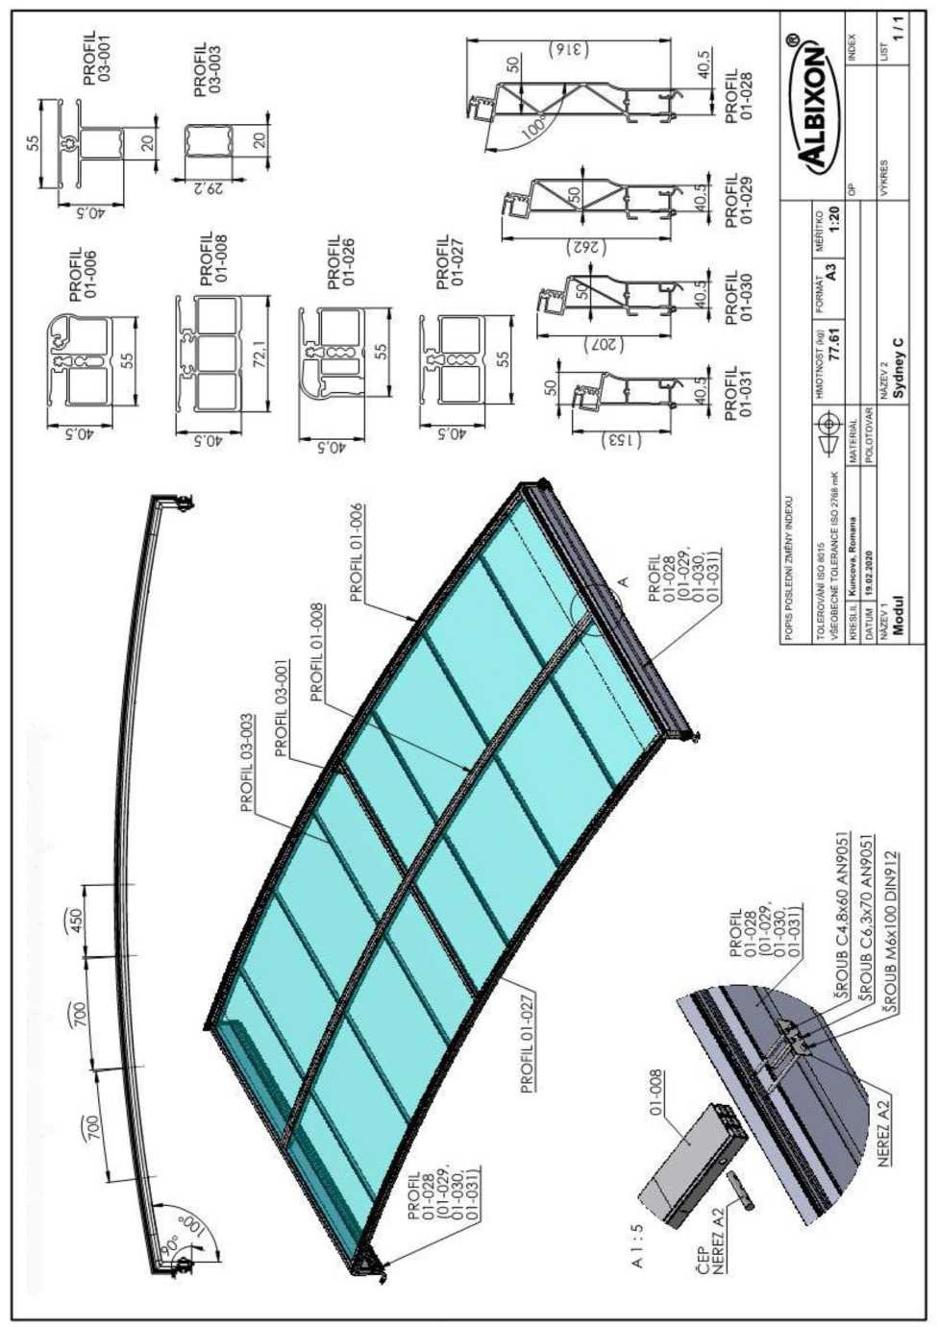

ROZMÍSTĚNÍ VZPĚR (PROFIL 03-003) A DĚLÍCÍHO PROFILU (PROFIL 03-001) | LAYOUT OF STRUTS (PROFILE 03-003) AND DIVIDING PROFILE (PROFILE 03-001)
PROFIL | PROFILE
ČEP | PIN
NEREZ | STAINLESS STEEL
ŠROUB | SCREW
POPIS POSLEDNÍ ZMĚNY INDEXU | DESCRIPTION OF LATEST INDEX CHANGE
TOLEROVANÍ ISO 8015 | TOLERANCE ISO 8015
VŠEOBECNÉ TOLERANCE ISO 2768 mK | GENERAL TOLERANCES ISO 2768 mK
KRESLIL | DRAWN BY
DATUM | DATE
NÁZEV 1 | TITLE 1
MATERIÁL | MATERIAL
POLOTOVAR | INTERMEDIATE
HMOTNOST (kg) | WEIGHT (kg)
NÁZEV 2 | TITLE 2
FORMAT | FORMAT
MĚŘÍTKO | SCALE
VÝKRES | DRAWING
INDEX | INDEX
LIST | SHEET

Rod elements
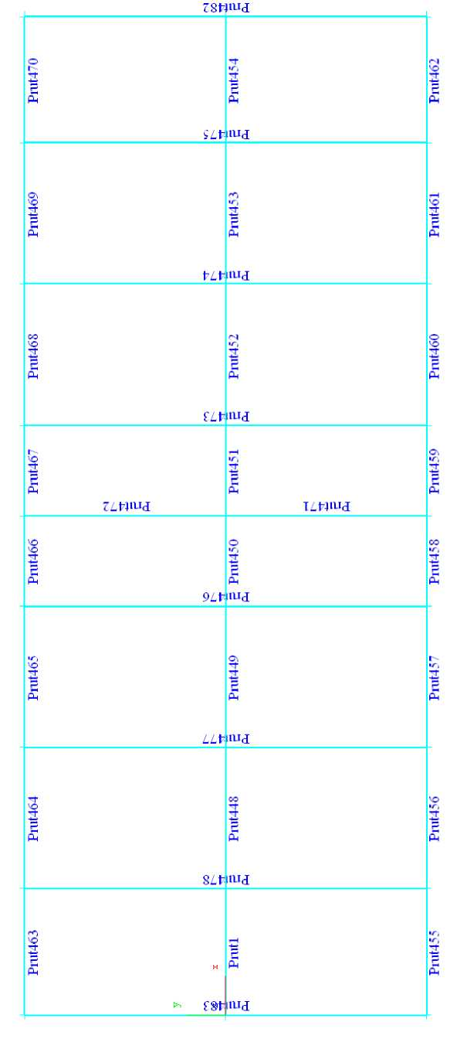
Rod | Rod

Structure assessment Roof loading by snow KZS 1 = 1.1 x ZS 1 + ZS 2
The results of the entire structure assessment - internal forces, all rods, total limits for the module
Derived comparative tension for EN AW 6063 σ = 142.3 MPa
Derived comparative tension for PC 1000 polycarbonate σ = 142 MPa

Loading scheme KZS 1:

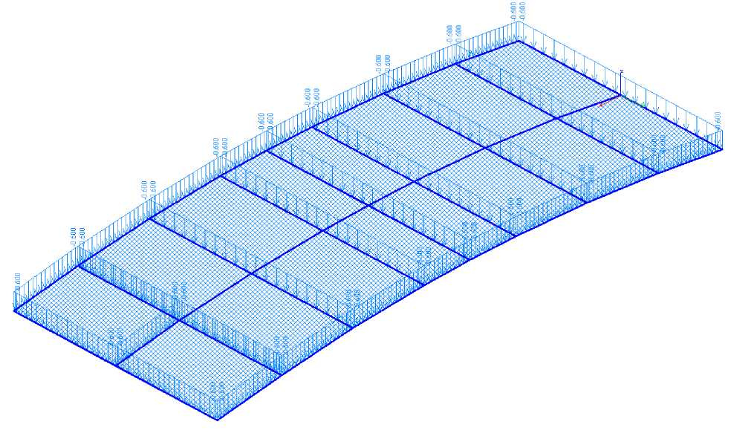

Results of the assessment - internal forces, all rods, selected results, total limits

Sig.min, Sig.max [MPa] Tension on outer fibres

Limits for result: KZS1 - snow
Rod | Position | Sig.min | Sig.max
 | [m] | [MPa] | [MPa]
Rod478 | 1.000 | -27.438 | 31.633
Rod482 | 0.500 | -0.014 | 0.011
Rod451 | 0.000 | -10.859 | -9.674
Rod478 | 1.000 | -27.438 | 31.633

The design is compliant, the comparative tension is not reached.

Results of the assessment - deformation, all rods, selected results, total limits
Ux, Uy, Uz [mm] displacements in axes
Utotal [mm] total displacements
Limits for result: KZS1 snow
Rod | Position | Ux | Uy | Uz | Utotal
 | [m] | [mm] | [mm] | [mm] | [mm]
Rod475 | 1.500 | -0.331 | 0.010 | -2.742 | 2.762
Rod478 | 0.500 | 0.331 | -0.010 | -2.741 | 2.760
Ro461 | 0.352 | -0.098 | -0.048 | -1.205 | 1.209
Rod464 | 0.352 | 0.097 | 0.048 | -1.202 | 1.207
Rod477 | 0.500 | 0.265 | -0.011 | -3.522 | 3.532
Rod477 | 0.500 | 0.265 | -0.011 | -3.522 | 3.532

The ratio of max. deflection and assessed structure span of 5000 mm is 1: 1415

The curve of tension on the structure from KZS 1:
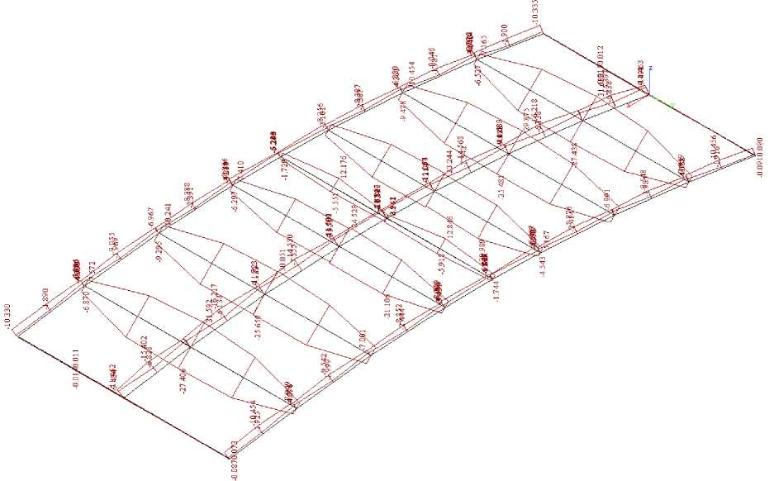
The curve of deformation on the structure from KZS 1:

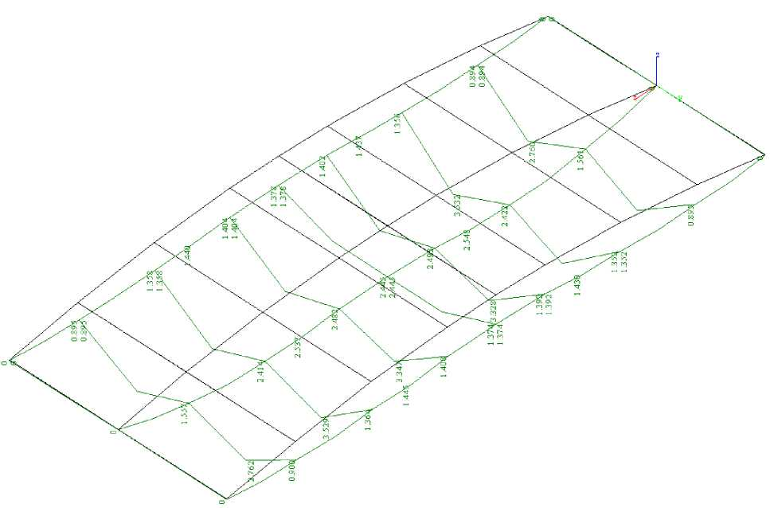

Results of the assessment - internal forces, all surfaces, panels

sx, sy, sxy, sef [MPa] Tension in local axes
Derived comparative tension for PC 1000 4 mm polycarbonate panels σ = 142 MPa

Limits for result: KZS1 snow

Area | Node | Position | sef | sef | sef
 |  |  | top | median | bottom
 |  | [m] | [MPa] | [MPa] | [MPa]
Polygon22 | 110 | 2.478, 1.000, 0.231 | 0.087 | 0.073 | 0.067
Polygon25 | 63 | 1.328, -0.500, 0.181 | 7.772 | 0.665 | 8.999
Polygon22 | 110 | 2.478, 1.000, 0.231 | 0.087 | 0.073 | 0.067
Polygon25 | 63 | 1.328, -0.500, 0.181 | 7.772 | 0.665 | 8.999
Polygon22 | 110 | 2.478, 1.000, 0.231 | 0.087 | 0.073 | 0.067
Polygon25 | 63 | 1.328, -0.500, 0.181 | 7.772 | 0.665 | 8.999

Isolines of tension in panels:

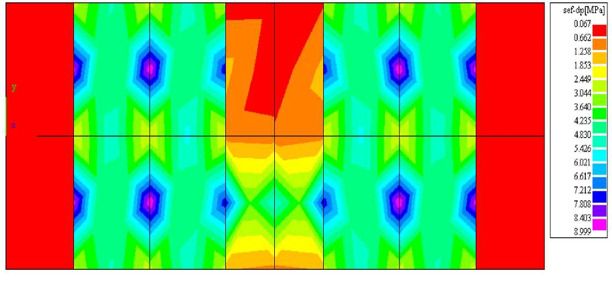

Results of the assessment - transformation, all surfaces, panels

Ux, Uy, Uz [mm] displacements in axes
Utotal [mm] total displacements

Limits for result: KZS1 snow

Area | Node | Position | Uz | Utotal
 |  | [m] | [mm] | [mm]
Polygon21 | 159 | 3.170, 0.354, 0.209 | -28.317 | 28.367
Polygon21 | 159 | 3.170, 0.354, 0.209 | -28.317 | 28.367

Isolines of transformation in panels:

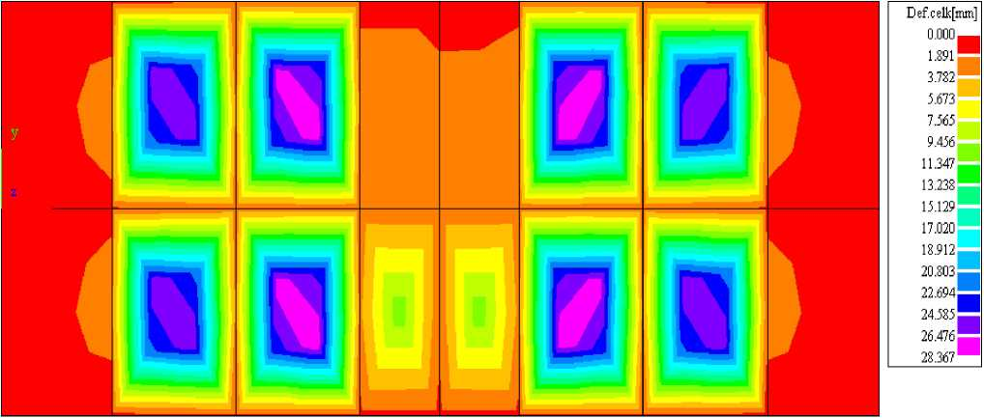
Def.celk[mm] | Def. total [mm]

Structure assessment Roof loading by load superposition KZS 2 = 1.1 x ZS 1 + ZS 3

The results of the entire structure assessment - internal forces, all rods, total limits for the module

Derived comparative voltage for calculated effective values for Al σ = 142.3 MPa

Loading scheme KZS 3:
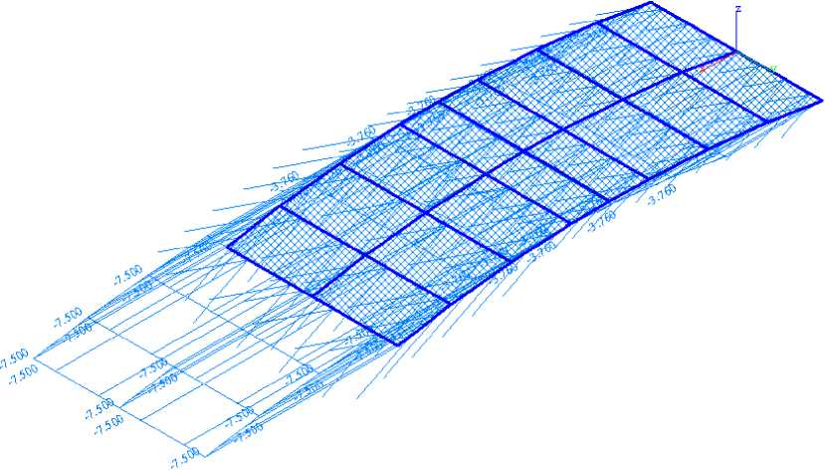

Results of the assessment - internal forces, all rods, selected results, total limits
Sig.min, Sig.max [MPa] Tension on outer fibres
Derived comparative tension for PC 1000 4 mm polycarbonate panels σ = 142.3 MPa
Limits for result: KZS2 - loading superposition
Rod | Position | Sig.min | Sig.max
 | [m] | [MPa] | [MPa]
Rod453 | 0.352 | -120.183 | 87.525
Rod454 | 0.636 | 7.437 | 9.362
Rod1 | 0.000 | -10.302 | -10.029
Rod449 | 0.000 | -78.272 | 100.523

Design complies, comparative tension not exceeded - compliant.

Results of the assessment - deformation, all rods, selected results, total limits
Ux, Uy, Uz [mm] displacements in axes
Utotal [mm] total displacements
Limits for result: KZS2 - loading superposition
Rod | Position | Ux | Uy | Uz | Utotal
 | [m] | [mm] | [mm] | [mm] | [mm]
Rod474 | 1.500 | -5.683 | -0.010 | -36.179 | 36.623
Rod469 | 0.704 | -4.186 | -0.055 | -25.172 | 25.518
Ro461 | 0.704 | -4.184 | 0.060 | -25.161 | 25.506
Rod474 | 1.500 | -5.683 | -0.010 | -36.179 | 36.623
Rod477 | 1.500 | -5.191 | 0.017 | 33.351 | 33.753
Rod474 | 1.500 | -5.683 | -0.010 | -36.179 | 36.623

The ratio of max. deflection and assessed structure span of 5000 mm is 1: 136
The curve of tension on the structure from KZS 2:
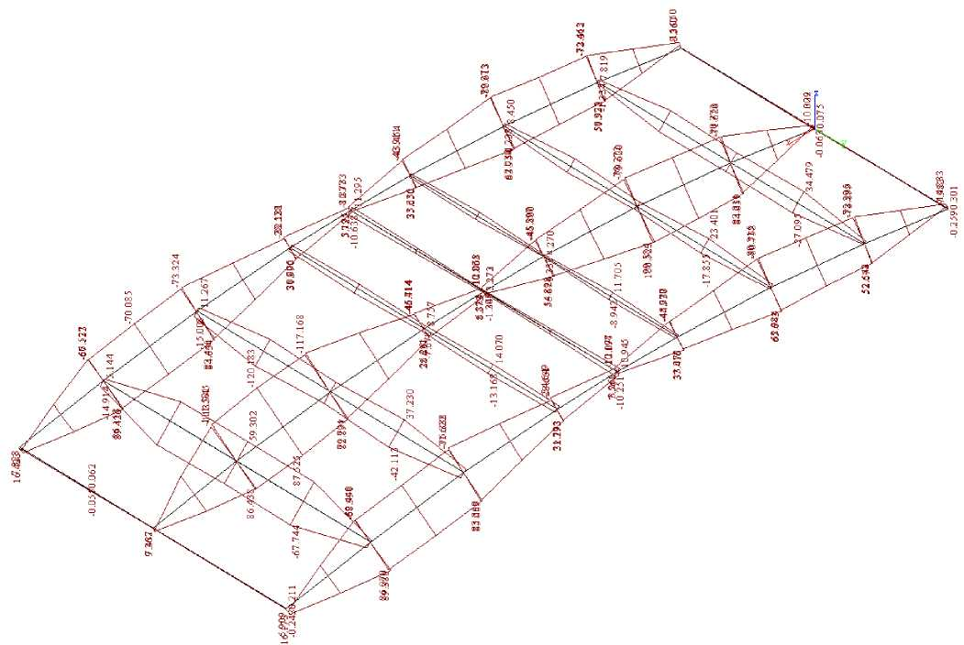
The curve of deformation on the structure from KZS 2:
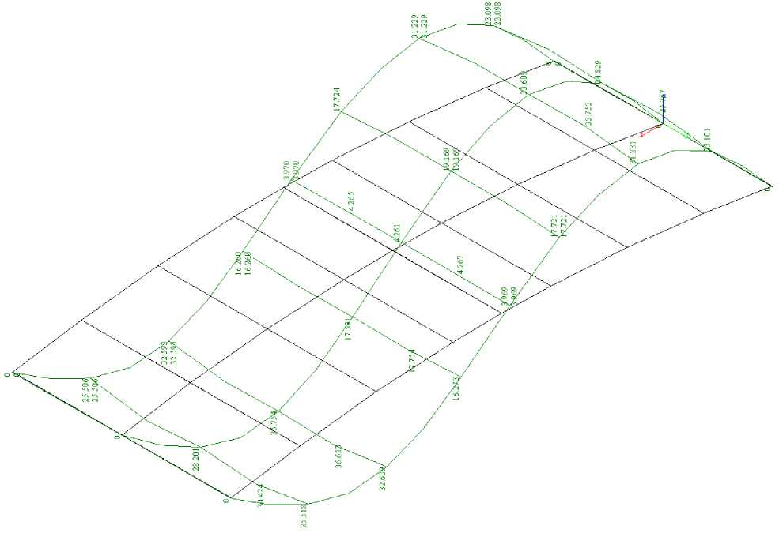

Results of the assessment - internal forces, all surfaces, polycarbonate panels
sx, sy, sxy, sef [MPa] Tension in local axes
Derived comparative tension for PC 1000 4 mm polycarbonate panels σ = 142 MPa
Limits for result: KZS2 - loading superposition

Area | Node | Position | sef | sef | sef
 |  |  | top | centerline | bottom
 |  | [m] | [MPa] | [MPa] | [MPa]
Polygon27 | 42 | 0.628, 0.000, 0.102 | 0.059 | 0.196 | 0.426
Polygon20 | 232 | 4.328, 0.500, 0.102 | 12.151 | 0.455 | 12.991
Polygon25 | 112 | 2.028, 0.000, 0.224 | 0.467 | 0.045 | 0.405
Polygon22 | 145 | 2.928, -0.500, 0.224 | 2.027 | 1.353 | 4.581
Polygon18 | 245 | 4.956, 0.500, 0.000 | 0.730 | 0.322 | 0.120
Polygon20 | 232 | 4.328, 0.500, 0.102 | 12.151 | 0.455 | 12.991

Isolines of tension in panels from KZS 2:

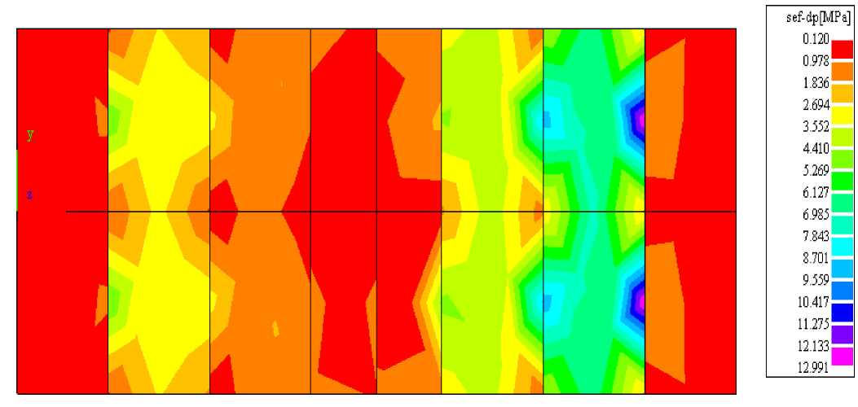

Results of the assessment - deformation, all rods, selected results, total limits
Ux, Uy, Uz |  | [mm] | displacements in axes
Utotal |  | [mm] | total displacements
Limits for result: KZS2 |  |  | by snow
 | Area | Node | Position | Ux | Uy | Uz | Utotal
 |  |  | [m] | [mm] | [mm] | [mm] | [mm]
 | Polygon20 | 194 | 3.870, 0.354, 0.154 | -9.549 | -8.516e-03 | -70.421 | 71.065
 | Polygon18 | 202 | 4.328, 1.000, 0.102 | -4.186 | -0.055 | -25.172 | 25.518
 | Polygon17 | 210 | 4.328, -1.000, 0.102 | -4.184 | 0.060 | -25.161 | 25.506
 | Polygon20 | 194 | 3.870, 0.354, 0.154 | -9.549 | -8.516e-03 | -70.421 | 71.065
 | Polygon26 | 72 | 1.087, 0.353, 0.154 | -6.760 | 0.012 | 47.428 | 47.907
 | Polygon20 | 194 | 3.870, 0.354, 0.154 | -9.549 | -8.516e-03 | -70.421 | 71.065
The ratio of max. deflection and assessed structure span of 5000 mm is 1: 71

Isolines of transformation in panels from KZS 2:

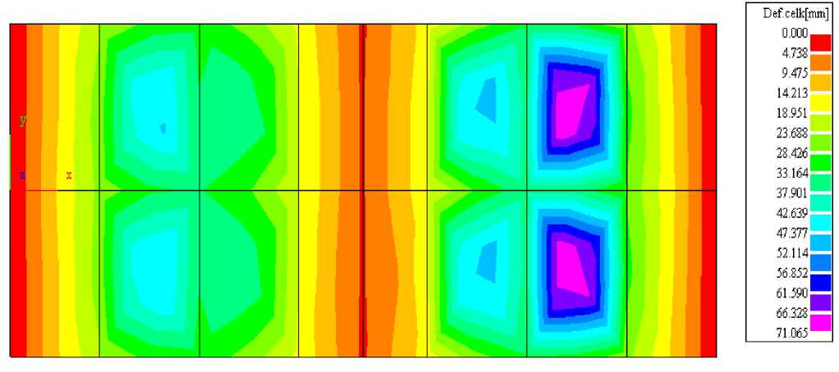
Def.celk[mm] | Def. total [mm]

Conclusion:

The assessment has shown that the SYDNEY C roof structure with the span of 5000 x 2190 mm is compliant for a snow load of 0.60 kNm⁻², in combination 1, with a self-load of 0.111 t. It is also compliant for wind snow, for a reference speed of 120 km/h⁻¹ (3.33 m.s⁻¹) in the above superpositions KZS 1; KZS 2. It has been shown that the designed roof structure meets the mechanical requirements for the limit strength, usability limit and planned life of 2.19*10⁵ hours according to EN 1991-1 and additional standards, and decrees specifying technical requirements for structures 268/09 Coll. as amended by Decree 20/12 Coll. Section 9 Mechanical resistance and stability.
It has been proven by the assessment that the structure cannot collapse, as neither of its parts reaches the limits of comparative tension.
There is no unacceptable transformation of the structure, as was demonstrated by the previous assessment.
There is no risk of damage to other parts of the building, or its technical facilities and installed equipment, due to unacceptable transformation.
Damage, in case of disproportionate extent to cause, is eliminated by the calculated degree of safety of Sb 2 for the main structures.

